Task 6: Biodiversity in a Local Ecosystem

Scientific Inquiry- VALIDATION

Name: _______________
Teacher: ______________
Mark: ______
Comment: __________________ ______________________________________________________________________________

Assessment type: Science Inquiry

Conditions- Validation

Test conditions
30minutes

Task weighting

5% of the school mark for this pair of units
Part One: Your Scientific Inquiry
You will need to use your Biodiversity of a Local Ecosystem Booklet to answer these questions.
- What was the purpose of this science inquiry?
_________________________________________________________________________________________________________________________(1 mark)
- Restate your original hypothesis. Explain why you made that prediction.
_________________________________________________________________________________________________________________________________________________________________________________________________________________________________________________________________________________________________________________________(2 marks)

- Do you think the Simplified Biodiversity Index is an accurate way to measure the biodiversity of the area? What are some advantages and disadvantages of using SBI to measure biodiversity?
_________________________________________________________________________________________________________________________________________________________________________________________________________________________________________________________________________________________________________________________________________________________________________________________________________________________________________________________________________________________________________________________(5 marks)

- Describe two ways you could improve the accuracy of this inquiry.
_________________________________________________________________________________________________________________________________________________________________________________________________________________________________________________________________________________________________________________________(2 marks)

- Write a conclusion for this inquiry. Refer to your hypothesis and data collected in both locations.
_________________________________________________________________________________________________________________________________________________________________________________________________________________________________________________________________________________________________________________________________________________________________________________________________________________________________________________________________________________________________________________________________________________________________________________________(5 marks)

Part Two: Interpreting New Data

You will need to use the attached data to answer the following questions.

- Complete the tables for Syed. Calculate the Total Wildlife in School Yard and the Simplified Biodiversity Index for both sites. (10 marks)

- Which site has the greatest biodiversity. Use your calculations to support your answer.
_________________________________________________________________________________________________________________________________________________________________________________________________________________________________________________________________________________________________________________________(3 marks)

- After looking at his collection documents, Syed’s teacher told him his data could have influenced by some environmental conditions. What conditions is the teacher talking about?
_________________________________________________________________________________________________________________________________________________________________________________________________________________________________________________________(2 marks)

- Syed was asked to redo his collection for site 2 because “he didn’t keep ______ constant”. What didn’t Syed keep constant? Why do you think he was asked to redo his collection for site 2?
_________________________________________________________________________________________________________________________________________________________________________________________(1 mark)

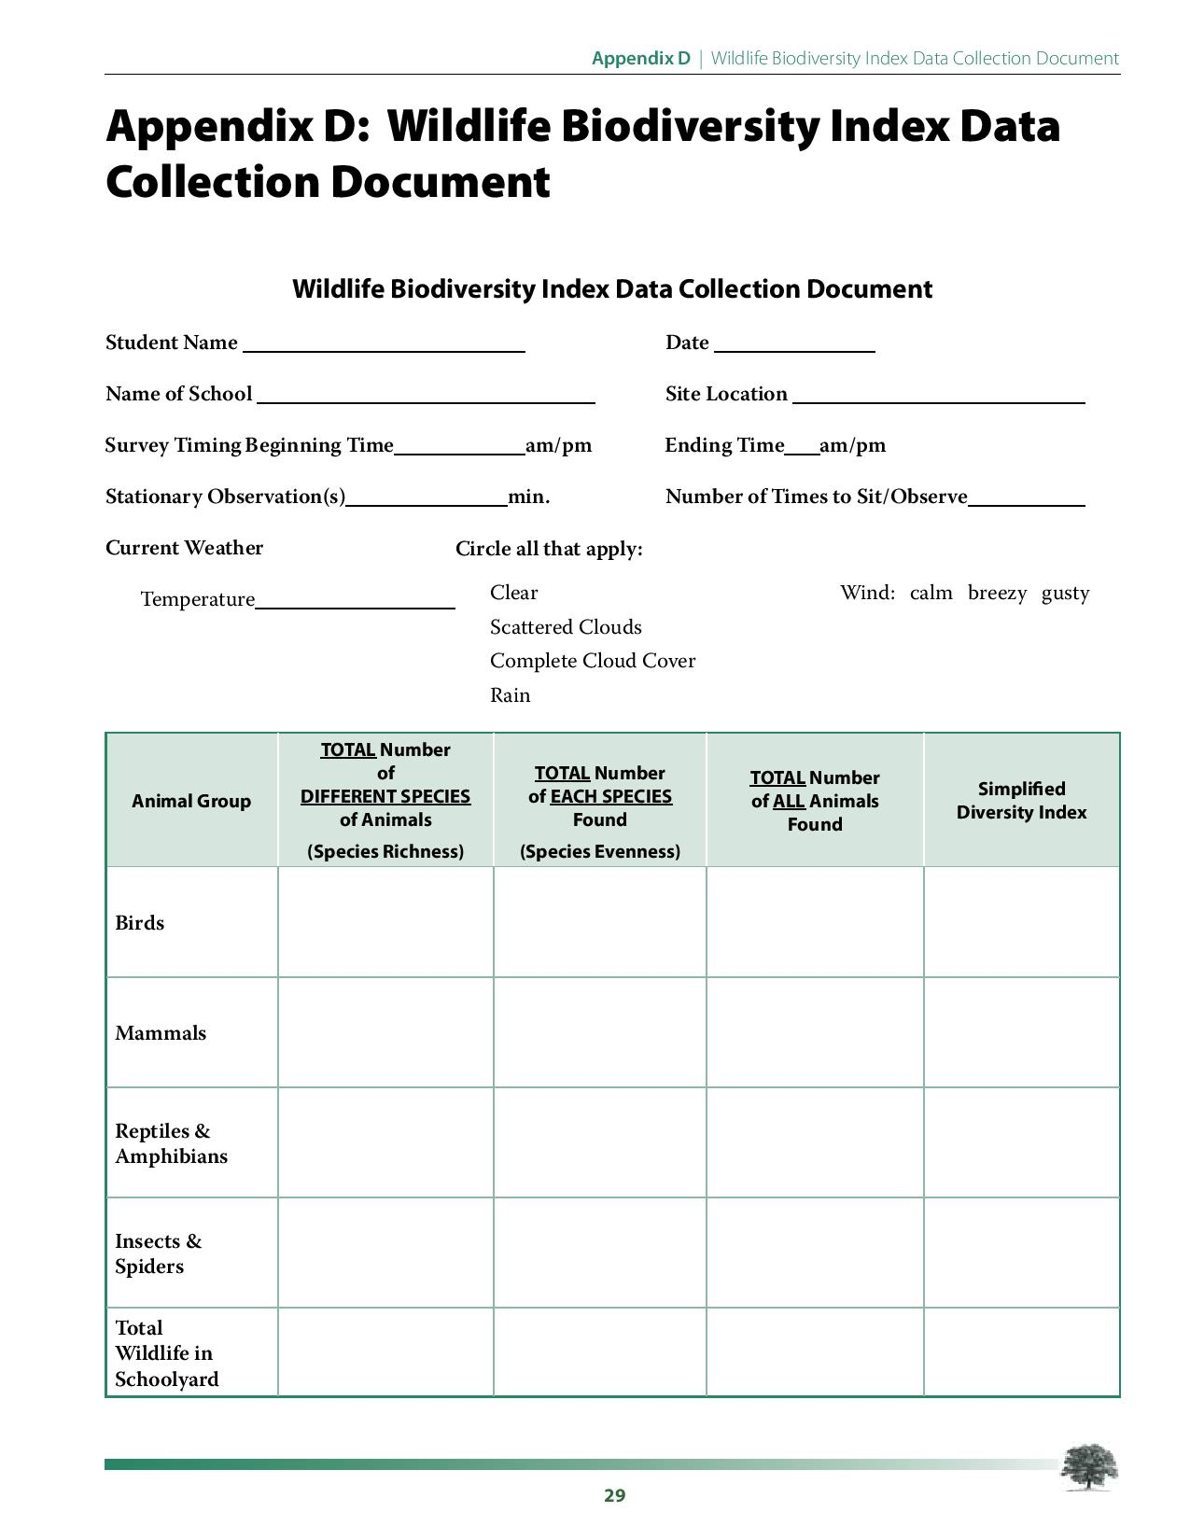
Syed used the Wildlife Biodiversity Index Data Collection Document to collect data
Species One: \ \

Species One: \\\\ \\\\ \\\\ \\\\ \\\\
Species Two: \\\\ \
Species Three: \\\\ \\\
Species Four: \\
Species One: \\\\ \\\\ \
Species Two: \\
22⁰C
3
6
2.01pm
2.31
Site 1
Very Cool School
19/05/21
Syed


Species One: \\ \\\\ \\
Species Two: \\\\
Species One: \\\ \\\

14.2⁰C
3
1
10am
10.30
Site 2
Very Cool School
20/05/21
Syed
Species One: \\ \

